**Assignment No. 1**

**Title:** Demonstrate the different types of topologies and types of transmission media by using a packet tracer tool.

**OBJECTIVES:**

The objectives of this assignment are:

1. To understand the basic types of network topologies used in computer networks.
2. To implement Bus, Star, Ring, Mesh, Point-to-Point, Tree, and Hybrid topologies in Cisco Packet Tracer.
3. To understand various types of transmission media (Copper, Fiber Optic, Wireless, etc.).
4. To analyze the working and behaviour of network topologies in real-time scenarios.

**1.Introduction to Computer Network**

A **computer network** is a system where multiple devices (such as computers, printers, and servers) are connected to share resources and communicate with each other. The main components of a network include:

* **Devices (Nodes)**: These are the devices connected to the network, like computers or smartphones.
* **Transmission Media**: The medium (wired or wireless) that carries data, such as Ethernet cables, fiber optics, or Wi-Fi.
* **Routers/Switches**: Devices that direct data to its destination.
* **Protocols**: Rules that govern how data is transmitted, like **TCP/IP**.

**Types of Networks:**

* **LAN (Local Area Network)**: A small network, like in a home or office.
* **WAN (Wide Area Network)**: A large network that covers a broad area, such as the **Internet**.

**Benefits of Networks:**

* **Resource Sharing**: Devices and data can be shared easily.
* **Communication**: Enables email, video calls, and instant messaging.
* **Remote Access**: Allows access to network resources from anywhere.

**Challenges:**

* **Security**: Ensuring the protection of data.
* **Scalability**: Handling growth in the network size.
* **Reliability**: Ensuring the network is always available.

**2.Networking Topologies**

Network topology refers to the arrangement of devices and connections in a computer network. It defines how network devices like computers, routers, and switches are physically or logically connected and how data flows between them. Different topologies, such as bus, star, mesh, and ring, offer varying levels of performance, scalability, and fault tolerance. The choice of topology impacts network efficiency, cost, and expansion. Understanding network topology is essential for designing reliable and scalable networks.

Each topology has its specific use cases, and the choice depends on factors like network size, budget, and performance requirements.

**a) Point-to-Point Topology**

In Point-to-Point topology, two devices are directly connected via a dedicated communication link.

**Advantages:**

* **Dedicated Communication:** Ensures a dedicated channel between two devices, leading to faster data transfer rates.
* **Simplicity:** Easy to set up and manage due to the direct connection.
* **Security:** Direct communication reduces the chances of data interception.

**Disadvantages:**

* **Limited Scalability:** Supports only two devices, making it unsuitable for larger networks.
* **Single Point of Failure:** If the link fails, the entire communication between the two devices is disrupted.
* **Costly for Expansion:** Adding new devices requires establishing separate links, which can be expensive and time-consuming.

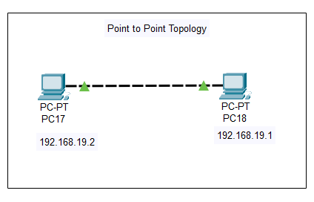

**b) Mesh Topology**

In Mesh topology, each device is connected to every other device in the network, either directly or indirectly.

**Advantages:**

* **High Reliability:** Multiple paths between devices ensure that if one link fails, data can be rerouted through another path.
* **Fault Isolation:** Failures in one part of the network do not affect the entire network.
* **High Data Transfer Rates:** Dedicated paths between devices allow for high-speed data transmission.

**Disadvantages:**

* **High Cost:** Requires a large number of connections, making it expensive to implement.
* **Complex Installation:** Setting up a mesh network is complex due to the numerous connections.
* **Maintenance Challenges:** Managing and maintaining the network can be difficult because of itscomplex structure, increasing size, security requirements, and the need for regular updates and monitoring.

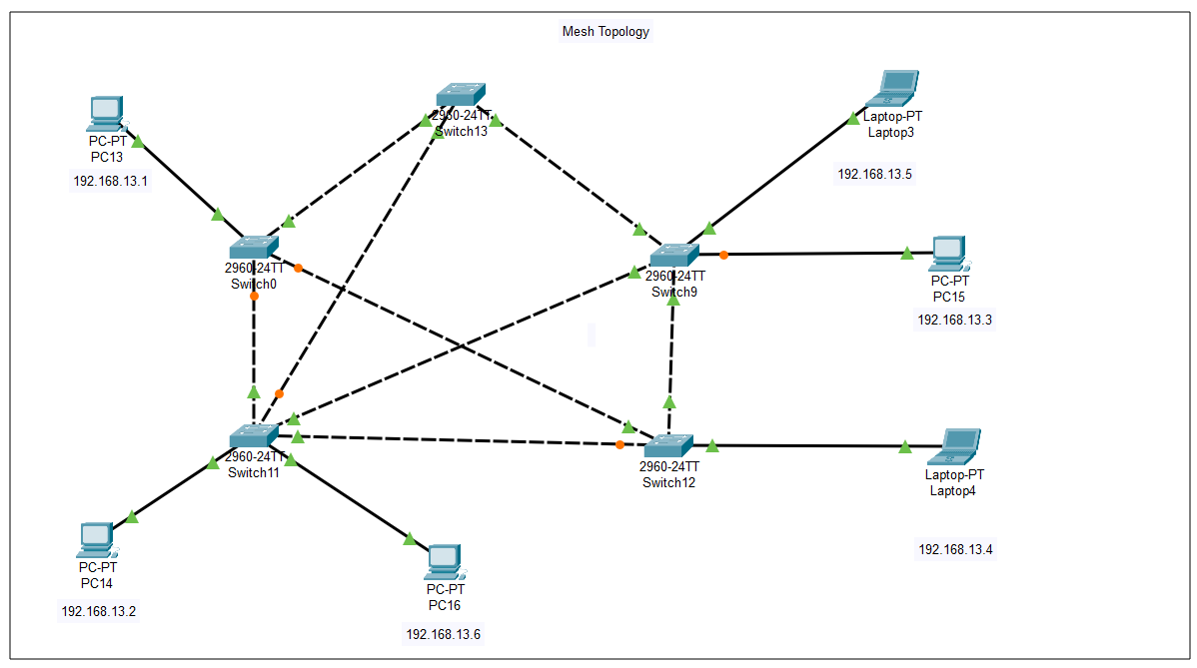

**c)Star Topology**

In Star topology, all devices are connected to a central device, such as a hub or switch.

**Advantages***:*

* **Easy to Install and Manage:** Adding or removing devices is straightforward and does not disrupt the network.
* **Fault Isolation:** If one device fails, it does not affect the rest of the network.
* **Scalability:** New devices can be added easily without affecting the existing network.

**Disadvantages:**

* **Single Point of Failure:** If the central hub fails, the entire network is affected.
* **High Cost:** Requires more cabling and a central device, increasing the overall cost.
* **Performance Bottleneck:** The central device can become a bottleneck if not properly managed.

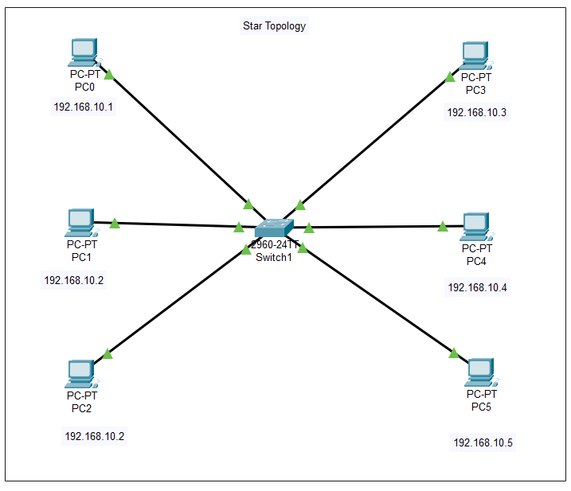

**d) Bus Topology**

In Bus topology, all devices are connected to a single central cable, known as the bus or backbone.

**Advantages:**

* **Simplicity and Cost-Effectiveness:** Easy to set up and requires less cabling, making it suitable for small networks.
* **Flexibility:** New devices can be added by connecting them to the bus without affecting the rest of the network.

**Disadvantages:**

* **Limited Scalability:** Performance can degrade as more devices are added due to data collisions and network traffic.
* **Single Point of Failure:** If the main cable fails, the entire network is disrupted.
* **Maintenance Challenges:** Troubleshooting can be difficult because it's hard to isolate problems in the shared cable.

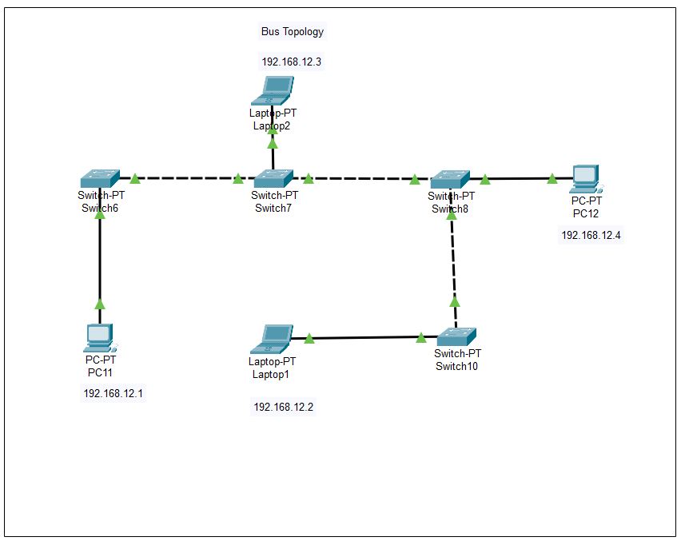

**e) Ring Topology**

In Ring topology, each device is connected to two other devices, forming a circular data path.

**Advantages:**

* **Efficient Data Transmission:** Data travels in one direction, reducing the chance of collisions.
* **Simple Installation:** Easy to install and configure for small networks.

**Disadvantages:**

* **Single Point of Failure:** If one device or connection fails, the entire network can be disrupted.
* **Difficult Troubleshooting:** Identifying and fixing issues can be challenging due to the continuous data flow.
* **Limited Scalability:** Adding new devices can be complex and may require network downtime.

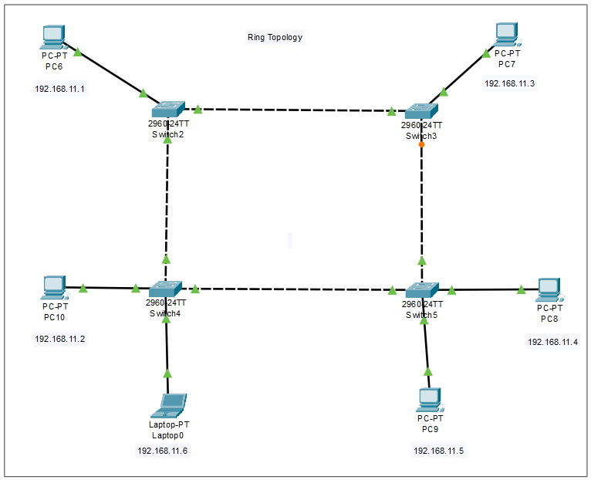

**f)Tree Topology**

Tree topology combines characteristics of both bus and star topologies, connecting multiple star networks to a central bus.

**Advantages:**

* **Hierarchical Structure:** Organizes networks in a tree-like structure, suitable for large organizations.
* **Scalability:** Easily accommodates additional devices or networks.
* **Fault Isolation:** Problems in one branch do not affect the entire network.

**Disadvantages:**

* **Complex Design:** Designing and implementing a tree topology can be complex.
* **Single Point of Failure:** The central bus acts as a single point of failure; if it fails, all connected networks are affected.
* **High Cost:** Requires more cabling and hardware, increasing installation and maintenance costs.

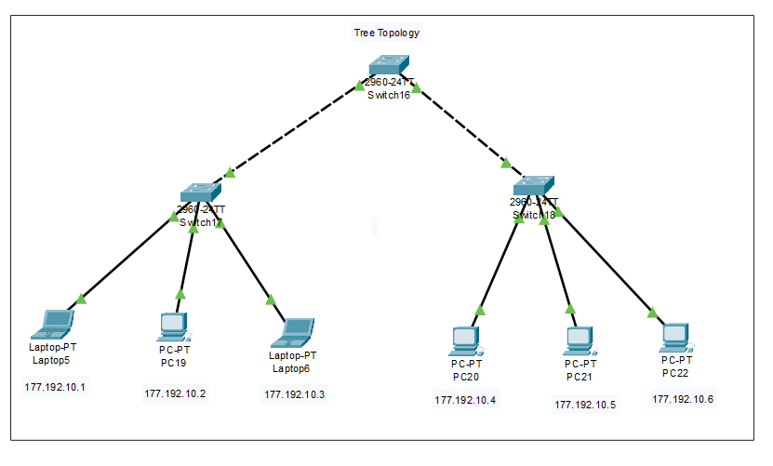

**g) Hybrid Topology**

Hybrid topology combines two or more different topologies to leverage the advantages of each.

**Advantages:**

* **Flexibility:** Can be tailored to meet specific organizational needs.
* **Scalability:** Easily accommodates growth and changes in the network.
* **Fault Isolation:** Faults in one part of the network do not necessarily affect other parts.

**Disadvantages:**

* **Complex Design and Maintenance:** Designing and maintaining a hybrid network can be complex and costly.
* **High Cost:** Requires more cabling, hardware, and management resources.
* **Difficult Troubleshooting:** Identifying and resolving issues can be challenging due to the network's complexity.

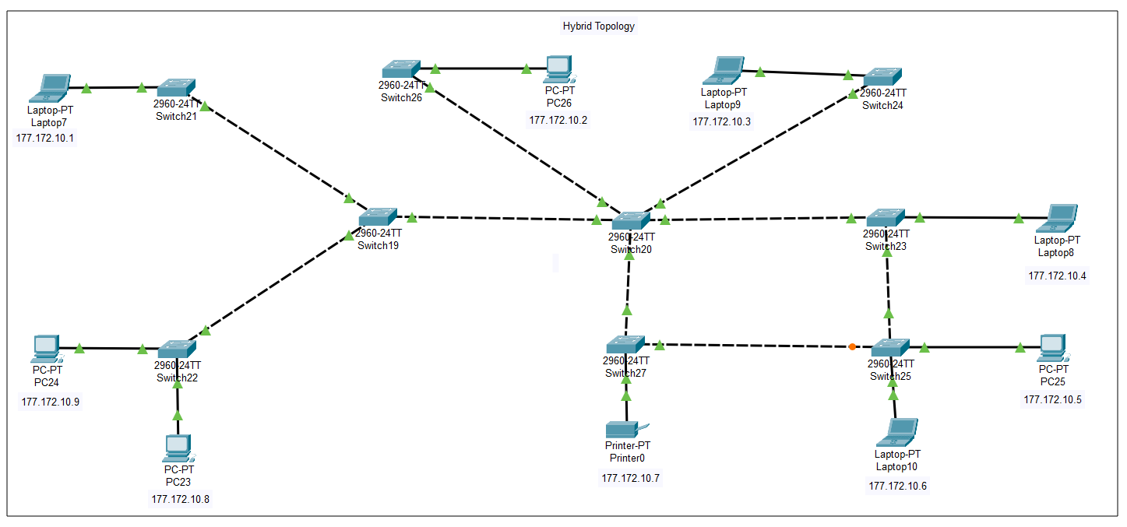

**3.Introduction to Cisco Packet Tracer**

**Cisco packet tracer:** Cisco Packet Tracer is a network simulation software developed by Cisco Systems. It enables users to design, configure, and troubleshoot virtual networks, providing a hands-on learning experience without the need for physical hardware. This tool is widely used in educational settings to teach networking concepts and prepare for certifications like CCNA (Cisco Certified Network Associate).

**Key Tools and Features in Cisco Packet Tracer:**

* **Device Simulation:** Allows users to add and configure various network devices such as routers, switches, and end devices.
* **Topology Creation:** Enables the design of network topologies by connecting devices with virtual cables, facilitating the visualization of network structures.
* **Configuration Interface:** Provides a command-line interface (CLI) and graphical user interface (GUI) for configuring devices, simulating real-world networking scenarios.
* **Protocol Simulation:** Supports the simulation of various network protocols, including routing protocols like RIP, OSPF, and EIGRP, allowing users to observe and analyze network behaviour.
* **Real-Time Simulation:** Offers real-time simulation capabilities to test and troubleshoot network configurations, helping users understand the impact of changes immediately.
* **Multi-User Functionality:** Supports multi-user mode, enabling collaboration among multiple users to work on the same network topology simultaneously.

These features make Cisco Packet Tracer a valuable tool for both beginners and professionals to practice and enhance their networking skills in a controlled, virtual environment.

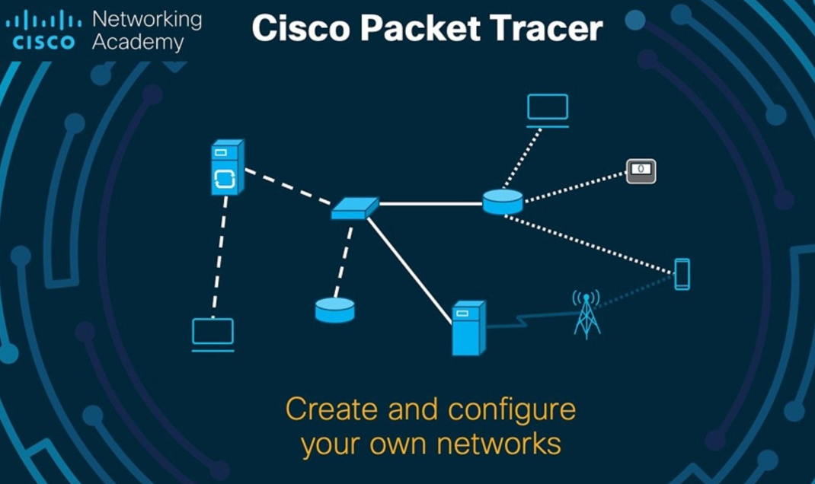

**4.Information about different tabs and devices (end nodes, switches, cables)**

**1. End Devices (End Nodes):**

End devices are the user devices that connect to a network to send and receive data. Common examples include:

* **PCs/Laptops**: Used for browsing, working, etc.
* **Servers**: Provide services like web hosting or file storage.
* **Printers**: Shared resources for printing over the network.
* **IP Phones**: Phones that use the internet for communication.

**2. Switches:**

A **switch** connects multiple devices in a LAN and directs data to the correct device based on **MAC addresses**.

* **Unmanaged Switches**: Simple, no configuration needed.
* **Managed Switches**: Offer configuration options like VLANs and traffic management.

**3. Cables:**

Cables connect devices in the network:

* **Ethernet Cables** (Twisted Pair): Used for most wired connections.
* **Fiber Optic Cables**: For high-speed, long-distance communication.
* **Coaxial Cables**: Used less frequently in modern networks.

**Tabs in Packet Tracer:**

1. **Devices Tab**: Contains all network devices (PCs, routers, switches, etc.).
2. **Connections Tab**: Choose the right cables for connections (Ethernet, Fiber, etc.).
3. **Config Tab**: Configure device settings (IP addresses, routing, etc.).
4. **Physical Tab**: Visualize how devices are physically connected.
5. **Simulation Tab**: Simulate data flow and network traffic.
6. **Desktop Tab**: Access settings on end devices like IP configuration and tools (ping/traceroute).

**5 .Configuration of components**

**End Devices(PCs,Laptop,Printers,Smartphones):**

**1. Interface: FastEthernet0**

* The device is connected via a Fast Ethernet interface.

**2. IPv4 Configuration**

* Static IP: The device is manually assigned an IP address instead of obtaining one dynamically via DHCP.
* IPv4 Address: 192.168.10.1 (A private IP address within the 192.168.10.0/24 subnet).
* Subnet Mask: 255.255.255.0 (Indicates a network with a range of 192.168.10.1 to 192.168.10.254).
* Default Gateway: 192.168.10.10 (The router or gateway that connects this network to other networks).
* DNS Server: 0.0.0.0 (Indicates that no DNS server is specified, so name resolution might not work).

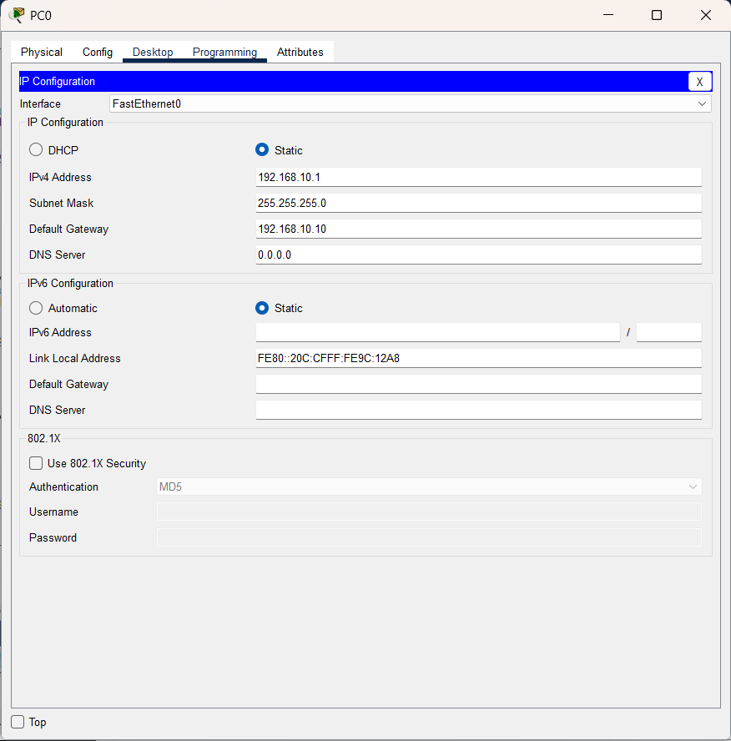

**6.ADDRESSING TABLE/ROUTING TABLE:**

**Here is the configuration table for each topology:**

**Star Topology**

|  |  |  |  |  |
| --- | --- | --- | --- | --- |
| Device Name | IP Address | Subnet Mask | Default Gateway | Interface |
| PC0 | 192.168.10.1 | 255.255.255.0 | 192.168.10.10 | FastEthernet0 |
| PC1 | 192.168.10.2 | 255.255.255.0 | 192.168.10.10 | FastEthernet0 |
| PC2 | 192.168.10.2 | 255.255.255.0 | 192.168.10.10 | FastEthernet0 |
| PC3 | 192.168.10.3 | 255.255.255.0 | 192.168.10.10 | FastEthernet0 |
| PC4 | 192.168.10.4 | 255.255.255.0 | 192.168.10.10 | FastEthernet0 |
| PC5 | 192.168.10.5 | 255.255.255.0 | 192.168.10.10 | FastEthernet0 |

**Ring Topology**

|  |  |  |  |  |
| --- | --- | --- | --- | --- |
| Device Name | IP Address | Subnet Mask | Default Gateway | Interface |
| PC6 | 192.168.11.1 | 255.255.255.0 | 192.168.11.10 | FastEthernet0 |
| PC7 | 192.168.11.3 | 255.255.255.0 | 192.168.11.10 | FastEthernet0 |
| PC8 | 192.168.11.4 | 255.255.255.0 | 192.168.11.10 | FastEthernet0 |
| PC9 | 192.168.11.5 | 255.255.255.0 | 192.168.11.10 | FastEthernet0 |
| PC10 | 192.168.11.2 | 255.255.255.0 | 192.168.11.10 | FastEthernet0 |
| Laptop0 | 192.168.11.6 | 255.255.255.0 | 192.168.11.10 | FastEthernet0 |

**Point-to-Point Topology**

|  |  |  |  |  |
| --- | --- | --- | --- | --- |
| Device Name | IP Address | Subnet Mask | Default Gateway | Interface |
| PC17 | 192.168.9.2 | 255.255.255.0 | 192.168.9.10 | FastEthernet0 |
| PC18 | 192.168.9.1 | 255.255.255.0 | 192.168.9.10 | FastEthernet0 |

**Tree Topology**

|  |  |  |  |  |
| --- | --- | --- | --- | --- |
| Device Name | IP Address | Subnet Mask | Default Gateway | Interface |
| Laptop5 | 177.192.10.1 | 255.255.255.0 | 177.192.10.10 | FastEthernet0 |
| PC19 | 177.192.10.2 | 255.255.255.0 | 177.192.10.10 | FastEthernet0 |
| Laptop6 | 177.192.10.3 | 255.255.255.0 | 177.192.10.10 | FastEthernet0 |
| PC20 | 177.192.10.4 | 255.255.255.0 | 177.192.10.10 | FastEthernet0 |
| PC21 | 177.192.10.5 | 255.255.255.0 | 177.192.10.10 | FastEthernet0 |
| PC22 | 177.192.10.6 | 255.255.255.0 | 177.192.10.10 | FastEthernet0 |

**Bus Topology**

|  |  |  |  |  |
| --- | --- | --- | --- | --- |
| Device Name | IP Address | Subnet Mask | Default Gateway | Interface |
| PC11 | 192.168.12.1 | 255.255.255.0 | 192.168.12.10 | FastEthernet0 |
| Laptop1 | 192.168.12.2 | 255.255.255.0 | 192.168.12.10 | FastEthernet0 |
| Laptop2 | 192.168.12.3 | 255.255.255.0 | 192.168.12.10 | FastEthernet0 |
| PC12 | 192.168.12.4 | 255.255.255.0 | 192.168.12.10 | FastEthernet0 |

**Mesh Topology**

|  |  |  |  |  |
| --- | --- | --- | --- | --- |
| Device Name | IP Address | Subnet Mask | Default Gateway | Interface |
| PC13 | 192.168.13.1 | 255.255.255.0 | 192.168.13.10 | FastEthernet0 |
| PC14 | 192.168.13.2 | 255.255.255.0 | 192.168.13.10 | FastEthernet0 |
| PC15 | 192.168.13.3 | 255.255.255.0 | 192.168.13.10 | FastEthernet0 |
| Laptop4 | 192.168.13.4 | 255.255.255.0 | 192.168.13.10 | FastEthernet0 |
| Laptop3 | 192.168.13.5 | 255.255.255.0 | 192.168.13.10 | FastEthernet0 |
| PC16 | 192.168.13.6 | 255.255.255.0 | 192.168.13.10 | FastEthernet0 |

**Hybrid Topology**

|  |  |  |  |  |
| --- | --- | --- | --- | --- |
| Device Name | IP Address | Subnet Mask | Default Gateway | Interface |
| Laptop7 | 177.172.10.1 | 255.255.255.0 | 177.172.10.10 | FastEthernet0 |
| PC26 | 177.172.10.2 | 255.255.255.0 | 177.172.10.10 | FastEthernet0 |
| Laptop9 | 177.172.10.3 | 255.255.255.0 | 177.172.10.10 | FastEthernet0 |
| Laptop8 | 177.172.10.4 | 255.255.255.0 | 177.172.10.10 | FastEthernet0 |
| PC25 | 177.172.10.5 | 255.255.255.0 | 177.172.10.10 | FastEthernet0 |
| Laptop10 | 177.172.10.6 | 255.255.255.0 | 177.172.10.10 | FastEthernet0 |
| Printer0 | 177.172.10.7 | 255.255.255.0 | 177.172.10.10 | FastEthernet0 |
| PC23 | 177.172.10.8 | 255.255.255.0 | 177.172.10.10 | FastEthernet0 |
| PC24 | 177.172.10.9 | 255.255.255.0 | 177.172.10.10 | FastEthernet0 |

**6.OUTPUT (Expected Results & Observations)**

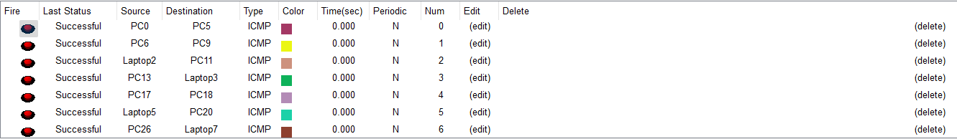

**7.Conclusion**

This assignment provided a comprehensive understanding of different network topologies and transmission media using Cisco Packet Tracer. By implementing various topologies such as Bus, Star, Ring, Mesh, Point-to-Point, Tree, and Hybrid, we analyzed their advantages, disadvantages, and real-world applications. Additionally, we explored different transmission media, including Copper, Fiber Optic, and Wireless, understanding their role in network communication. The practical implementation in Packet Tracer enhanced our ability to design, configure, and troubleshoot networks, reinforcing key networking concepts essential for building efficient and scalable network infrastructures.